Deliverable #2 Report

Subject Name: Software Engineering

Project Name: Online Unused Medicine Donation System

Group Members:  
• Taha (Roll No: 23L-2644)  
• Shahzeb (Roll No: 23L-2506)  
• Ali Ahmad (Roll No: 23L-2619)

Deliverable Number: D2

Date of Submission: 14-04-2025

# Project Title and Introduction

Project Title: Online Unused Medicine Donation System

The Online Unused Medicine Donation System is a desktop application that facilitates the donation and ordering of unused medicines. It connects donors and recipients to ensure medicine reuse and reduce waste.

# User Stories

US3: Request Medicines  
As a recipient, I want to request medicines so that I can receive the required medication.

• US3.1: As a recipient, I want to add multiple medicines with quantity.

• US3.2: As a recipient, I want to provide a delivery address for the order.

US4: Admin Approval  
As an admin, I want to approve medicine donations and orders to maintain quality control.

# Design

The following diagrams were created to represent system design.

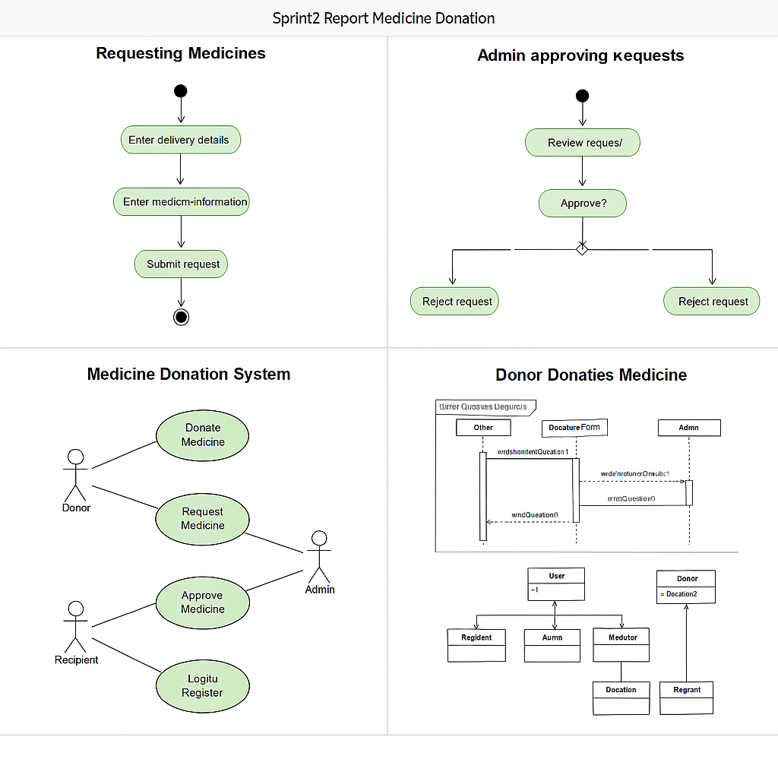

Figure: UML Diagrams - Activity, Use Case, Sequence, and Class

# Scrum Board

Snapshot 1: Initial Sprint Backlog Upload

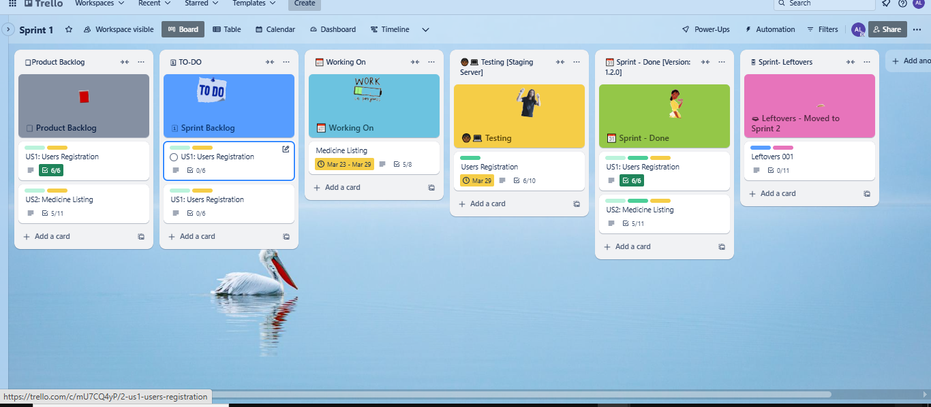

Snapshot 2: Mid-Sprint Progress

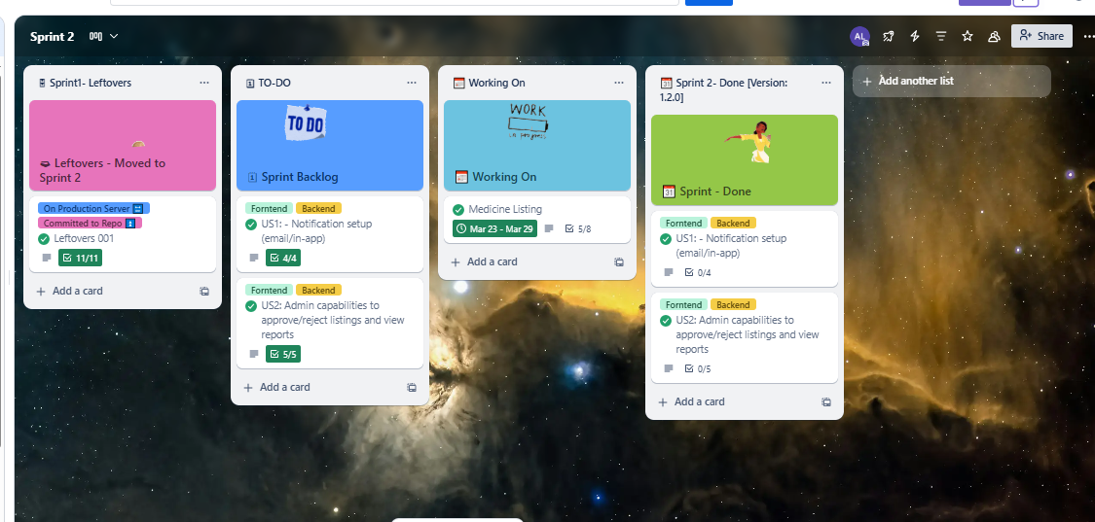

# Implementation Screenshots

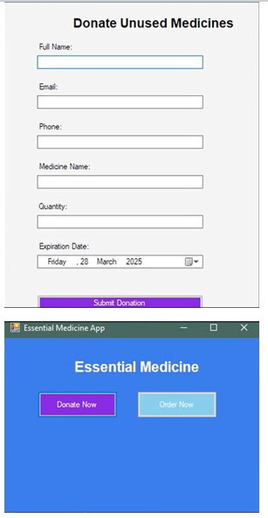

Donation Form UI



Order Medicines UI

# Work Division

|  |  |  |
| --- | --- | --- |
| Member | Role | Tasks Completed |
| Taha | Backend Developer | Implemented donation and order logic |
| Shahzeb | Frontend Developer | Developed order medicine UI |
| Ali Ahmad | QA & Testing | Performed UI testing and validations |